**MarketJS - Leaderboard API - Guide**

#### **Part A: Query User Data**

**URL:** <https://marketjs-vas.appspot.com/api/user/list>

**Method:** POST

**Body payload:**

* game_id: “6445513429745664”,
* secret_key: “12345”
* date: “07-01-2022”

**Response:** A JSON object containing the user data. Example:

{

"status": {

"message": "Successful",

"code": 200

},

"data": {

"timestamp": "08-04-2022 03:01",

"users": [{

"date": "07-01-2022",

"name": "Bobbie Jo Sweeney ",

"email": "bobbiejo10121401@gmail.com"

}, {

"date": "07-01-2022",

"name": "he56",

"email": "3h636@gstwrh.cp"

}]

}

}

**Example Postman configuration**

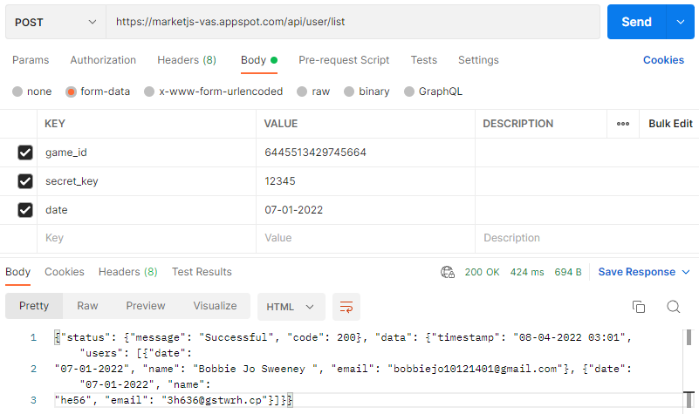

### 

#### **Part B: Query Leaderboard Data**

**URL:** <https://marketjs-vas.appspot.com/api/leaderboard_entry/read>

**Method:** POST

**Body payload:**

* output_type: “json”,
* game_id: “6445513429745664”
* interval: “alltime” // or “weekly”, “daily”

**Response:** A JSON object containing the leaderboard data. Example:

{

"status": {

"message": "Score retrieved",

"code": 200

},

"data": [{

"username": "Keir",

"first_name": "",

"last_name": "",

"name": "Keir",

"score_tiebreaker": "0",

"json_info": "",

"date_modified": "2022-07-06T12:24:20.722077+00:00",

"score": "4,087,435"

}, {

"username": "Shaw22",

"first_name": "",

"last_name": "",

"name": "Sharon Sombrero",

"score_tiebreaker": "0",

"json_info": "",

"date_modified": "2022-06-06T23:06:59.804693+00:00",

"score": "2,357,895"

}]

}

**Example Postman configuration**

